Members:

**M. Aman Ullah Khan (20K-1883)**

**Hammad (20K-1720)**

**M. Abdullah(20K-1729)**

Project Report

# Question 1: Error Prevention:

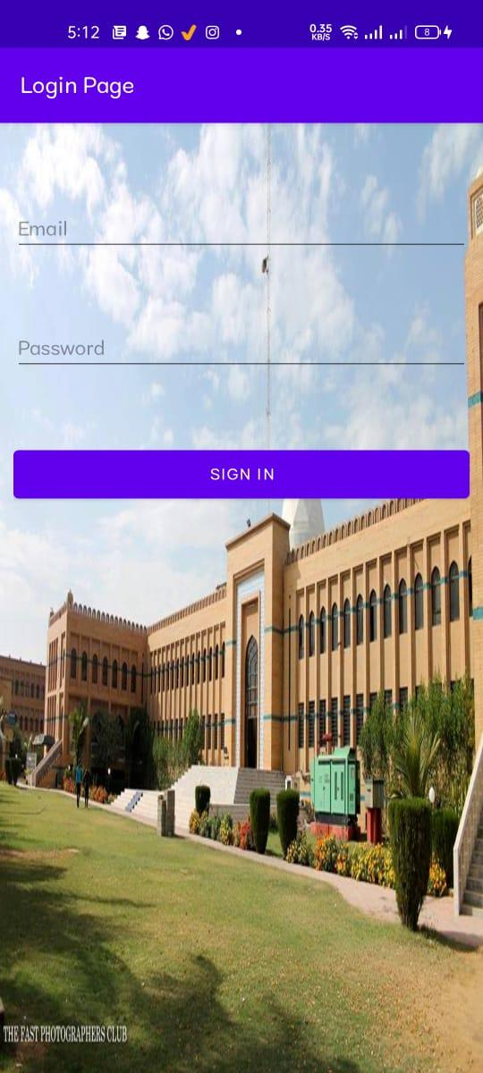

If the user will enter the wrong format of email the email field will lint red just like this in the picture

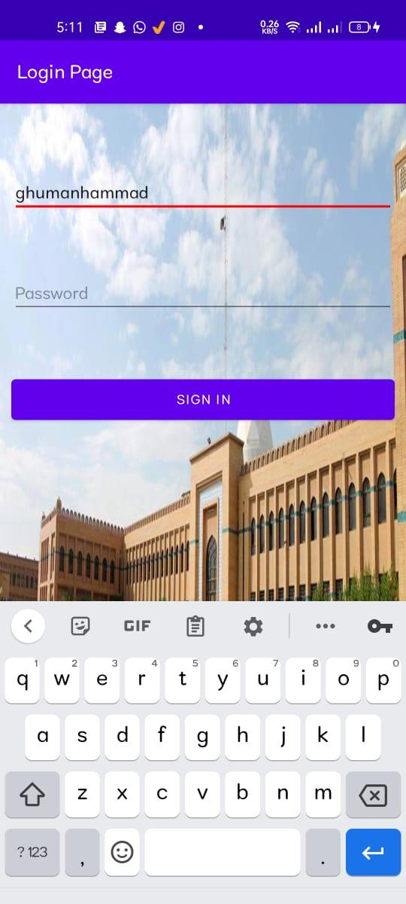

If the user will enter the email is correct format the field will not lint just like in the picture

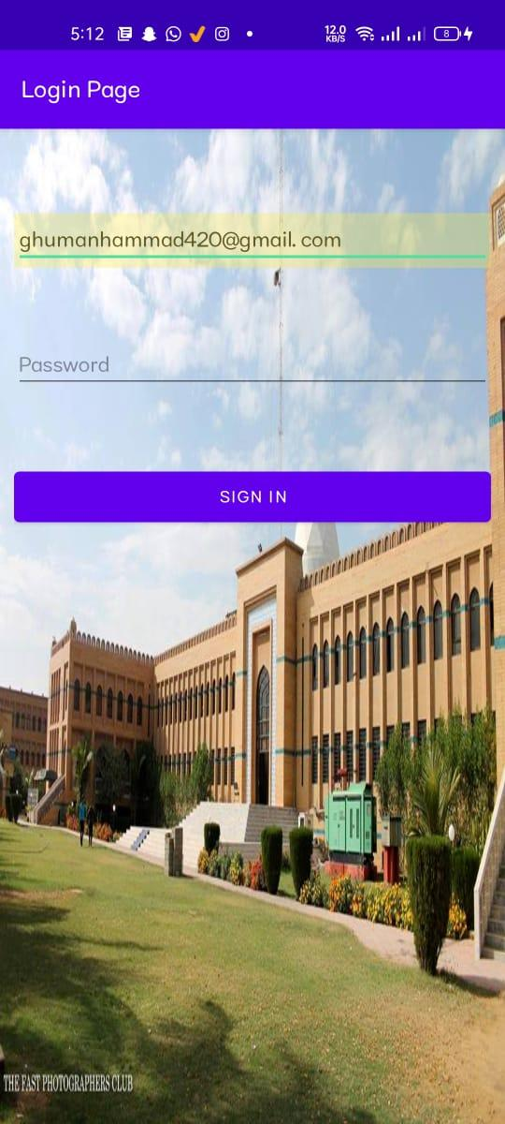

# Question no 2: Metaphor (Was delivered correct)

We use images of units as metaphors

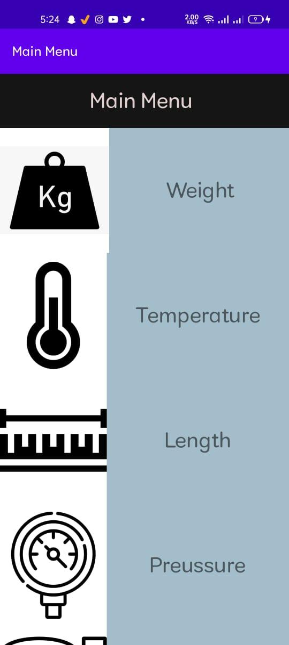

Question no 3: Browsability (Was delivered correct)

Browsability: ability to monitor without changing state mouse-over reveals what’s waiting. We achieve it by making a navigation drawer in which we know the changes without changing the state

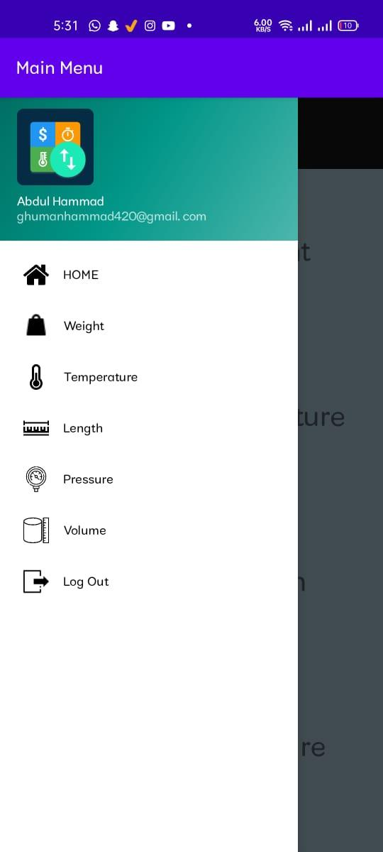

Question no 4 Persistence

Persistence refers to the characteristic of state of a system that outlives the process that created it. This is achieved in practice by storing the state as data in computer data storage. For example, we can achieve persistence by saving their documents to files. Here we have achieved it when the user press register button his data (username and password) is saved in database.

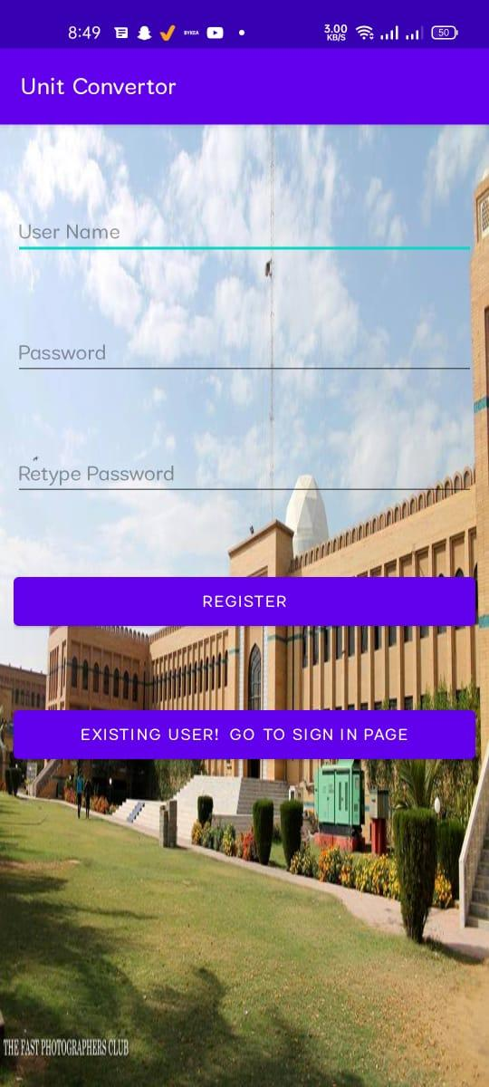

Question no 5 Task adequacy

Task adequacy is concerned with addressing the user's understanding of these tasks. It is necessary that system should allow the user to perform the desired tasks as defined during the task analysis. Here we have achieved in this way that user know what to give input, user knows that he cannot use decimal value for finding temperature.

